**Preliminary Design Report**

**Introduction**

The purpose of this proposed project is to develop an IoT platform that will monitor the available parking spaces in a parking structure. In efforts to help reduce the amount of time taken to find available spaces, this system would be developed to help alleviate the amount of time it takes for people to find a space to park their vehicles by managing and displaying available spaces.

**Operations overview**

The proposed IoT Platform will be designed on a based Ubuntu server. The platform is intended to be using LAMP stack and MySQL. The message broker that will be used is going to be MQTT (MQ Telemetry Transport). To provide constant updates about statuses of the parking sensors, communication between the platform and sensors should be relaying data transfers at the maximum speed required. The rule engine will be designed and serve as the platforms block for rules and conditions.

**Overall system diagram**

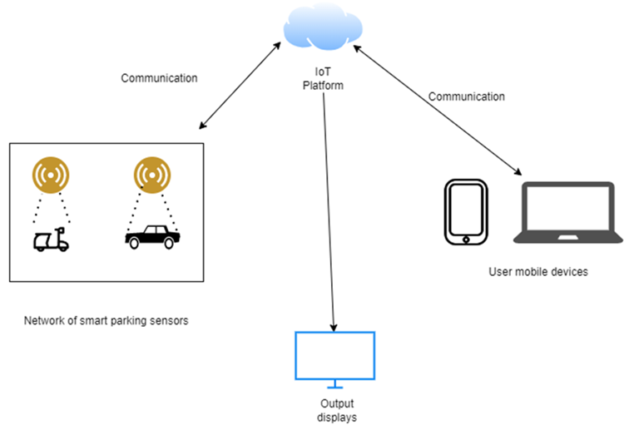

**The Preliminary Design Phase**

|  |
| --- |
| **Entry Criteria ---------->>>>>>> Exit Criteria**   * Requirements Analysis Report Generated - Requirements Analysis Report Generated * Software Development & Management - Software Development & Management Generated * Requirements and Specifications - Requirements and Specifications Generated |

|  |
| --- |
| **Product**   * Preliminary design report |
| **Measures**   * Staff hours * System Size * Employee size |
| **Methods and Tools**   * DigitalOcean * LAMP * Virutal hosts |

|  |
| --- |
| **Key Activities**  **Development Team:**   * This team will prepare the documentation * Conduct preliminary design and PDR   **Management Team:**   * This team will conduct training, and conduct training * Responsible for coordinating and planning the detailed design   **Requirements Definition Team:**   * This team is responsible for fixing issues |